PRODUCT DATA SHEET
PRODUCT DATA SHEET

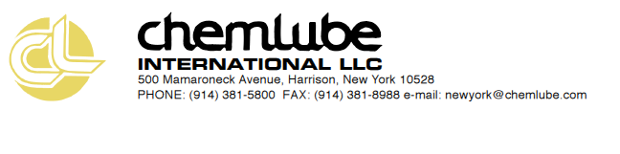

PRODUCT DATA SHEET

Chemlube Premium Gold Series

SAE 20W-50 /API SP

Chemlube Premium Gold is a premium engine oil that is formulated for turbo-charged and naturally spirited gasoline, propane, natural gas engines in passenger car and light duty truck service. The Premium 20W-50 meets or exceeds the API SP classification. This oil is designed for use in U.S., European, and Japanese passenger cars, vans, sport utility vehicles and light duty trucks.

Features | Applications
- Meets or exceeds API Service SN.  - Meets passenger car and light truck manufacturers warranty requirements.  - Lubricates, cools, and protects turbo-charged high-revving engines that operate at high temperatures.  - Protects the engine in controlling varnish, deposits, rust, corrosion, wear, and cleanliness.  - Designed to flow at low temperatures  to get to vital engine parts quickly. | - Passenger car and truck gasoline, propane, and natural gas engines specifying API service SN engine oils.  - Maintains the warranty requirements for today’s passenger car and light duty trucks.  - Reduces high temperature oxidation.  - Energy-Conserving for improved fuel  economy.  API license number 2325

SAE 20W-50 API SP TYPICAL PROPERTIES
Product Code 12050
TEST METHOD Typical
cSt @ 40ºC ASTM D445 161.1
cSt @ 100ºC ASTM D445 19.1
Viscosity Index ASTM D2270 135
CCS Viscosity, cP @-15ºC ASTM 5293 6500
Flash Point ºC ASTM D92 208
Pour Point ºC ASTM D97 -25
Color ASTM 1500 <3.5
Zinc, ppm Spectrometer 850
Phosphorus, ppm Spectrometer 790

NOTE: Values are typical only. Due to ongoing research, development and product improvement, product formulas are subject to change without notice. Chemlube International can not know all the uses this product may be subject to so it is the user’s responsibility to ascertain
that it is suitable for an intended use or application.

Reviewed 02-01-22

